**PRACTICAL- 1**

**AIM 1(a): Introduction to Computer Networking.**

**Computer Networking:** A computer network is a system of connected devices that enables the exchange of data and the sharing of resources. It’s more than just a group of computers—it includes various hardware components and software protocols that work together to ensure smooth communication. The main goal of a network is to support data transfer, resource sharing, and effective communication between devices.

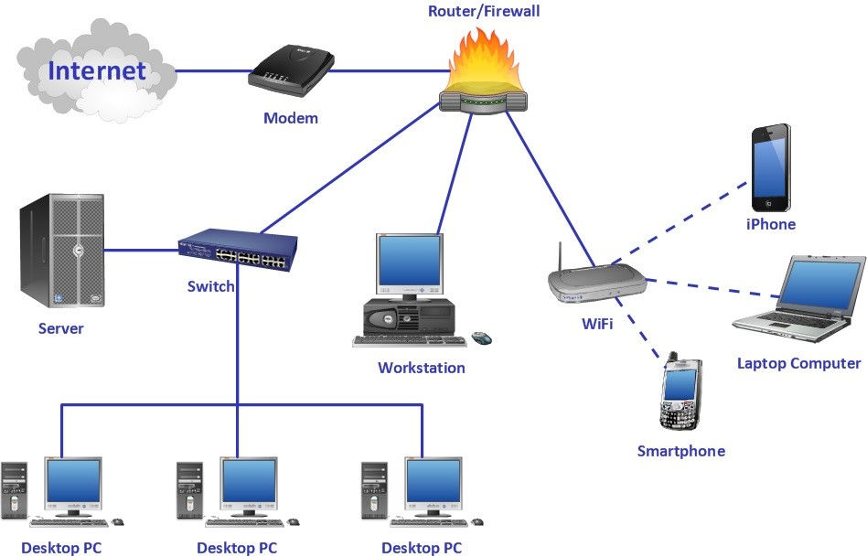

**Fig 1: Computer Network Structure**

**Types of Computer Networking:**

Computer Networks can be divided into 3 different categories:

* **PAN (Personal Area Network)**
* **LAN (Local Area Network)**
* **MAN (Metropolitan Area Network)**
* **WAN (Wide Area Network)**

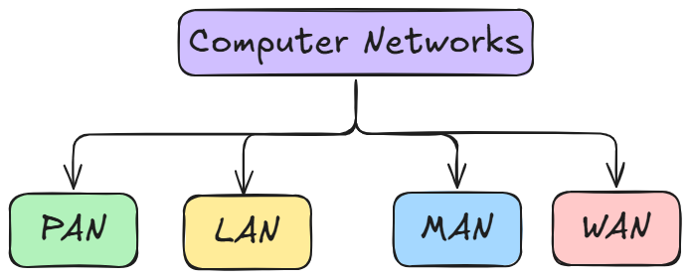

**Fig 2: Types of Networks**

1. **Personal Area Network:**

* A Personal Area Network (PAN) is the most basic type of computer network.
* It connects devices within a short range (typically 1–10 meters), centered around a single person or device.
* Usually operates from one or two primary devices.
* Connects only a few devices within a small, localized area.
* Enables communication and data sharing between personal devices such as smartphones, tablets, laptops, and wearables.
* **Example:** Using Bluetooth on a phone to share photos with nearby devices.
* **Advantages:**
* High transmission speeds
* Easy maintenance
* Very low costs

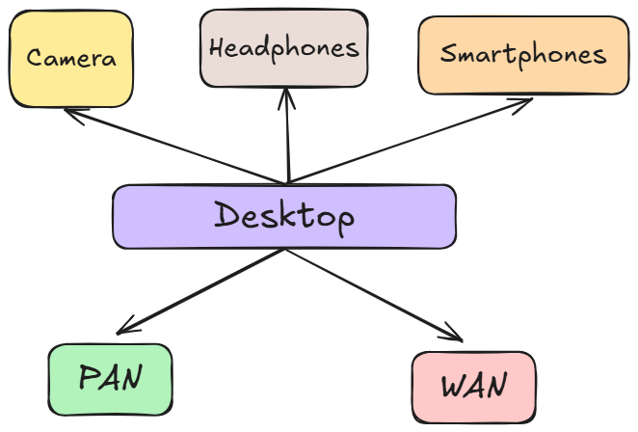

**Fig 3: Personal Area Network**

1. **Local Area Network:**
   * It is a network confined to a specific area, like a home, office, or campus.
   * Any network located within a single building or a group of nearby buildings is classified as a LAN.
   * It is the most commonly used type of computer network.
   * It connects a relatively small number of computers and devices.
   * Specifically designed for short-distance communication, typically up to around 2 kilometers.
   * Multiple LANs can be linked to enable broader communication and data sharing.
   * Commonly used for sharing resources like files, and internet access.
   * Key technologies that support LANs include Ethernet and Wi-Fi.

* **Advantages:**
  + Very High transmission speeds
  + Easy Maintenance
  + Low Cost

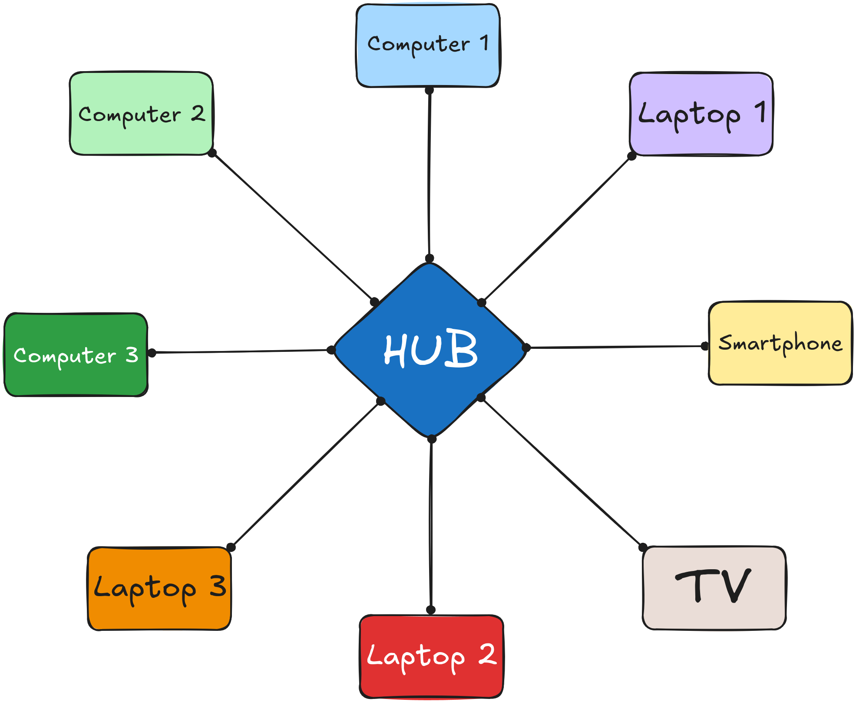

**Fig 4: Local Area Network**

1. **Metropolitan Area Network:**
   * A Metropolitan Area Network (MAN) covers a broader geographical area than a LAN but is smaller in scale than a WAN.
   * It typically spans a city, a large campus, or a metropolitan region.
   * MANs connect multiple LANs within the same city to enable wider communication and data sharing.
   * Commonly used by businesses, government agencies, universities, and ISPs to maintain connectivity across urban areas.
   * Utilizes high-speed transmission media such as fiber optic cables or wireless links.
   * Generally covers distances ranging from approximately 5 km to 50 km.
   * Offers moderate to high data transmission speeds.
   * Example: A city-wide public Wi-Fi network or a company’s branch offices within a city linked together.

* **Advantages:**
  + Wider coverage than LAN
  + High speeds compared to WAN
  + Supports efficient sharing of regional resources

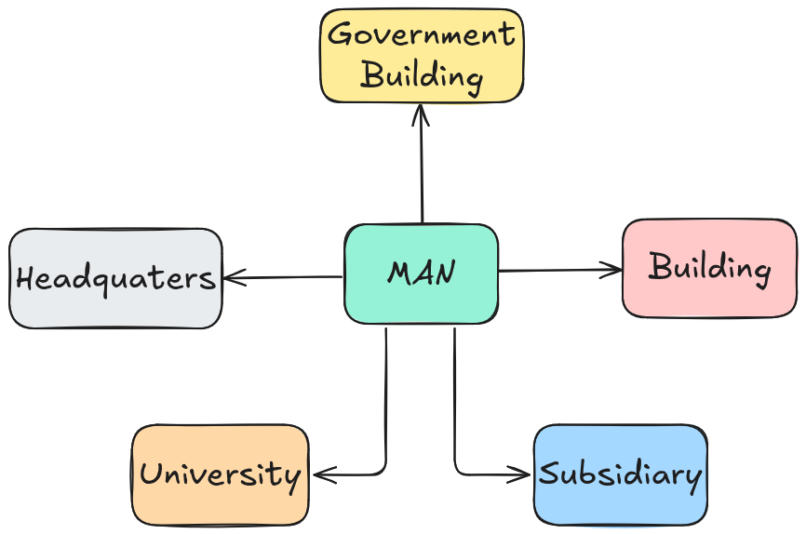

**Fig 5: Metropolitan Area Network**

1. **Wide Area Network:**
   * A Wide Area Network (WAN) spans a vast geographical area, such as a country, continent, or even the entire globe.
   * It connects multiple LANs and MANs to enable long-distance communication and data sharing.
   * As the largest type of network, it is commonly used by multinational corporations, governments, and telecommunications providers.
   * The Internet is the most well-known example of a WAN.
   * Transmission media include satellite links, fiber optic cables, microwave transmissions, and undersea communication cables.
   * There is no distance limitation; WANs can cover thousands of kilometers.
   * Transmission speeds are generally slower than those of LANs and MANs, due to greater distances and higher traffic loads.
   * WANs involve a more complex infrastructure, requiring routers and the use of public communication links.

* **Advantages:**
  + Covers unlimited distance
  + Enables global communication
  + Connects remote offices and users worldwide

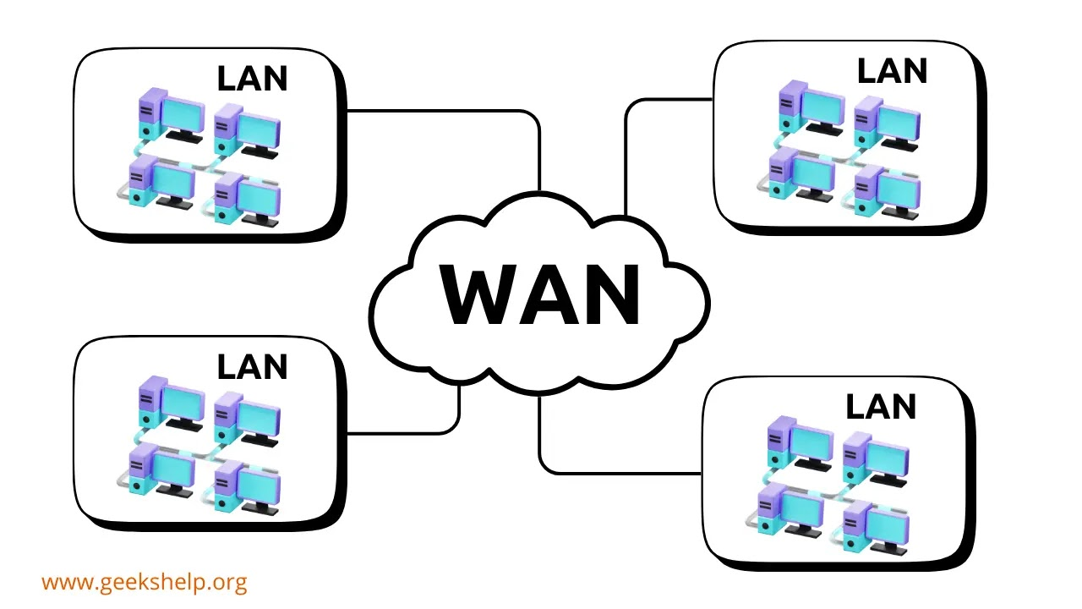

**Fig 6: Wide Area Network**

**Data Flow:** Transmission mode, also referred to as communication mode or data flow, defines how data is transferred between two devices over a communication channel—such as optical fiber, copper wires, wireless media, or storage devices. It determines the direction in which information flows between the devices and is sometimes known as a directional mode. Data is typically transmitted as electromagnetic waves or digital signals, with the Physical Layer of the OSI model responsible for ensuring the correct and reliable transfer of this data.

**Transmission modes consists of three types:**

* **Simplex**
* **Half-duplex**
* **Full-duplex**

1. **Simplex:**
   * In this mode, communication goes only in **one direction**.
   * The sender can transmit information, but the receiver has no way to reply back.
   * It’s mainly used where feedback isn’t necessary, so the process stays simple.
   * **Examples:** Keyboards, radio, etc.

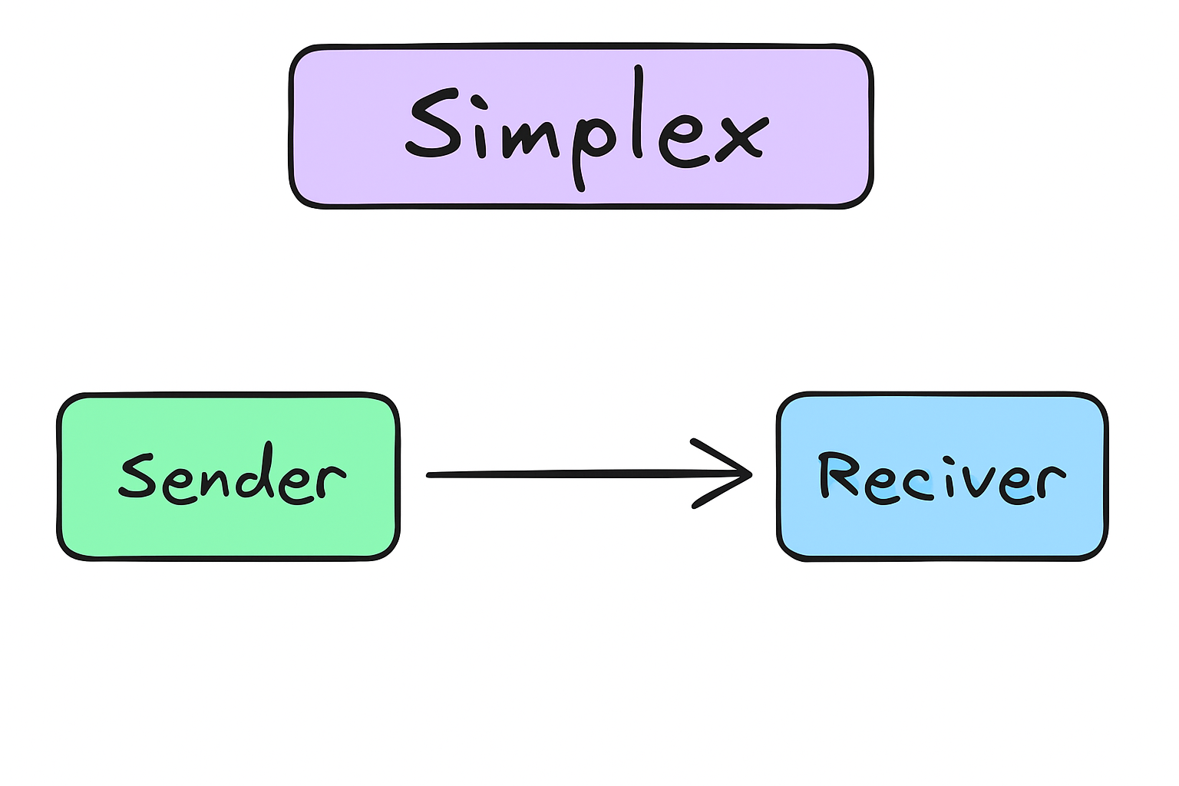

**Fig 7: Simplex Data Flow**

1. **Half-Duplex:**
   * In this, communication works in **both directions**, but **not at the same time**.
   * When **one device is sending**, the **other must wait** and only then reply.
   * This back-and-forth style makes it slower than full duplex, but still useful where two-way communication is needed.
   * **Example:** Walkie-talkies, etc

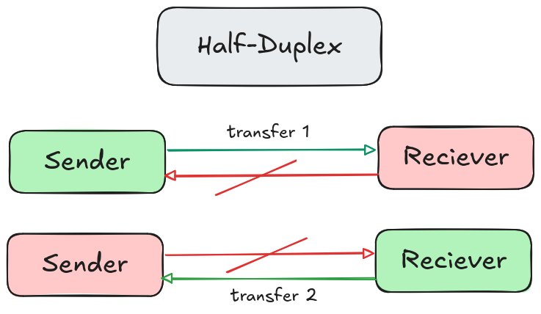

**Fig 8: Half-Duplex Data Flow**

1. **Full-Duplex:**
   * In this mode, communication happens in **both directions at the same time**.
   * Both devices can **send and receive data simultaneously**, which makes it the fastest and most efficient method.
   * It’s used in real-time communication where delays can’t be afforded.
   * Example: Telephone calls, video calls, etc.

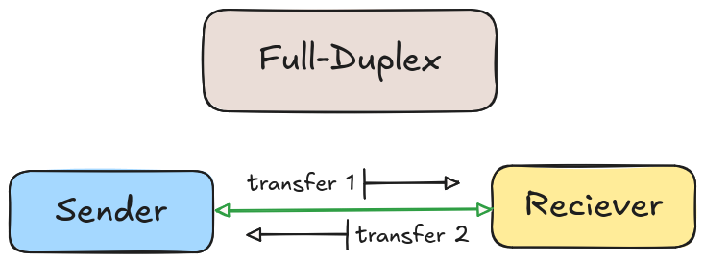

**Fig 9: Full-Duplex Data Flow**

**Applications of Computer Networking:**

1. **Business Applications:**
   * Enables smooth communication between employees and departments through emails, video calls, and messaging platforms.
   * Allows sharing of resources such as printers, servers, and software across the organization.
   * Supports remote access so employees can work securely from home or while traveling.
   * **Examples:** Microsoft Teams, Slack, etc.
2. **Educational Applications:**
   * Provides access to online study materials, e-books, and recorded lectures.
   * Supports virtual classrooms and online exams through e-learning platforms.
   * Encourages collaboration between students and teachers via forums, video calls, and group projects.
   * **Examples:** Google Classroom, Moodle, etc.
3. **Healthcare Applications:**
   * Stores and shares patient records digitally, reducing paperwork and errors.
   * Enables telemedicine, allowing patients to consult doctors online.
   * Supports collaboration between hospitals by sharing diagnostic data and research findings.
   * **Example:** Hospitals using digital health records, teleconsultation services, etc
4. **Entertainment Applications:**
   * Provides access to online games, music, and video streaming platforms.
   * Allows real-time multiplayer gaming and live streaming without interruptions.
   * Makes content globally available for creators and audiences.
   * **Example:** Watching movies and shows on Netflix, playing games on Steam, etc.
5. **Military Applications:**
   * Uses private, secure networks for defense communication and coordination.
   * Helps in intelligence sharing, satellite-based navigation, and surveillance.
   * Ensures safety of classified information during military operations.
   * **Example:** The U.S. Defense Information Systems Network (DISN) used for secure military communications, etc.
6. **Scientific Applications:**
   * Facilitates collaboration between researchers across the globe.
   * Supports data sharing, simulations, and joint experiments.
   * Provides access to supercomputers and large research databases.
   * **Example:** CERN (European Organization for Nuclear Research) uses networks to share particle physics data worldwide, etc.
7. **Transportation Applications:**
   * Used to monitor and control traffic signals and reduce congestion.
   * Helps track vehicles through GPS and optimize routes.
   * Manages airline reservations, train schedules, and logistics systems.
   * **Examples:** Uber, Rapido, Ola, etc.